Journal of the Statistical and Social Inquiry Society of Ireland
Vol. ---------

Changing Patterns of Secondary Employment in Ireland

Harry Williamson
Dr. Dermot P. Coates
Shannen Enright
Karen Hogan

Irish Government Economic and Evaluation Service

Abstract: Over recent years, Ireland’s labour market and economy have outperformed expectations and having successfully weathered the disruption caused by the COVID-19 pandemic, employment levels reached a record high of 2.64m by mid-2023. In tandem with this expansion of the workforce, the number of those employed in more than one job – or those with secondary employment – has also risen. By mid-2023, 3.5 per cent of persons in employment in Ireland worked multiple jobs, compared to 1.9 per cent in 2002. Despite this increase, Ireland still has one of the lowest rates of secondary employment in the EU27. In absolute terms, by mid-2023, 87,700 persons aged 15-64 years in Ireland were working in two, or more, jobs (compared to 30,000 persons two decades earlier). A further 5,200 persons aged 65 years and over were doing likewise, bringing the total to almost 93,000. Second (or indeed, third) jobs tend to be concentrated in the agricultural and services sectors with the latter having undergone significant expansion in recent years. This paper presents a detailed profile of those in secondary employment. It also considers the intersection between full and part-time work in both a person’s principal and secondary employment and examines patterns in the volume of hours worked.

Keywords: secondary employment, opportunity, necessity, labour markets, Ireland, Europe

JEL: J01, J08, J21, J60, J81

- INTRODUCTION

The Irish labour market has experienced a remarkable recovery in the aftermath of the COVID-19 pandemic, with employment levels reaching a record high of 2.64m by mid-2023, some 285,000 higher than in Q4 2019. With unemployment rates in Ireland also low, the Irish economy can be considered to be at “full employment”. While much recent work has focussed on this remarkable labour market recovery and, more generally, on labour market dynamics post-pandemic – including employment transitions (Boyd, Keenan, and McIndoe-Calder, 2022; Coates, Dwan-O’Reilly and McNelis, 2021) – there has been a relative lack of research on the theme of persons working multiple jobs. This latter cohort are those persons with additional paid work activity. These are workers employed with a public or private entity and/or in self-employment alongside their primary job (hereafter: secondary employment). By mid-2023, there were 92,900 persons working more than one job in Ireland, an increase of 180% in the past 20 years.
This research complements work by the Revenue Commissioners (Murphy, 2023) which examined a sub-set of those with multiple jobs over a limited period. There remains, however, a dearth of research on the characteristics of people who work multiple jobs in Ireland, and the factors which determine whether someone has more than one job. Other questions, such as how Ireland compares to the rest of Europe for secondary employment rates, whether the incidence rate of secondary employment can be used as a proxy for primary job quality, and the reasons for working more than one job, remain largely unanswered. This paper aims to contribute to future policy debate on the issue of secondary employment and presents a detailed analysis of those working multiple jobs in Ireland. It also considers the intersection between full and part-time work in both a person’s principal and secondary employment and analyses patterns in the volume of hours worked.
The next Section looks at the data used in this paper followed by Section 3 which provides an overview of broader structural changes occurring in the Irish labour market over the past two decades. The latter also reviews the existing literature on topic of secondary employment, highlighting potential motivations behind multiple job holding. We then look further into the underlying characteristics of the persons that work multiple jobs and the nature of their employment – whether an employee or self-employed in either (or both) jobs – in the remaining Sections.

- DATA AND METHODOLOGY

The data sources used for analysis in this paper include Eurostat custom tabulations on the number of persons with multiple jobs, split by country, age, gender, occupation, and hours worked. We also use data generated by the Central Statistics Office (CSO). The timeframe under analysis in this paper is Q2 2002 to Q2 2023. Standard LFS definitions of employment are used throughout this paper (i.e., a person who during the reference week worked for at least one hour for pay or profit, including contributing family workers). It also includes persons who were not at work due to holidays, training, working time arrangements, illness, or other leave. In the LFS, it is multiple job holders themselves who designate which job they consider to be their primary job. In cases where this is doubtful, the primary job is assigned to the one with the greatest number of hours usually worked. In line with the definition of employment above, is important to note that volunteering is not considered to be a form of employment and is thus not included here. The available data does not allow us to comment definitively on the reasons why a person is working multiple jobs (i.e. financial necessity versus a planned career change).

One important point to note here is that official statistics capturing secondary employment are likely to underestimate the true number of persons working multiple jobs in the population. This is for a number of reasons. Firstly, the potentially transitory nature of second job holding means that it may often be missed from official statistics, as LFS definitions of secondary employment require someone to have undertaken secondary work within the ‘reference week’. Shorter-term, or irregular, second jobs may therefore be missed from LFS results. It could also be the case that some individuals may not perceive irregular odd jobs or short-term projects as a second ‘job or business’. Data from the Revenue Commissioners (Murphy, 2023) shows that there were 85,000 persons in Ireland who had received income from two employers during October 2022. As this cohort (employee in both primary and secondary job) makes up approximately 40% of total secondary employment (see Section 5), it would suggest that there could be up to c. 200,000 multiple-job holders in Ireland.

Secondly, another factor influencing the level of secondary employment in a country is likely to be the size of the shadow economy. One element of the shadow economy is the ‘shadow labour force’. Shadow labour force activities can include undeclared income from a primary job, unreported secondary employment, or being involved in the sale of illegal goods/services. It is unknown how many persons work in the shadow/informal economy in Ireland, although research by Medina and Schneider (2018), valued Ireland’s shadow economy at 9.6 per cent of GDP in 2015.

- UNDERLYING STRUCTURAL CHANGES IN THE IRISH LABOUR MARKET

The change in Ireland's labour market following the COVID-19 pandemic has been driven largely by increased female labour force participation, with 1.26 million women employed by Q2 2023 (an increase of approximately 170,000 since late 2019). Factors contributing to this rise include the expanded availability of remote work, enhancing flexibility in scheduling, commuting, and childcare (Williamson, 2022). A strong economic recovery post-pandemic and demographic shifts – younger workers replacing older ones with lower participation rates – have also bolstered employment gains (Boyd et al., 2021). Ireland's labour market has undergone significant sectoral changes over the past decade. Employment in construction has expanded significantly whilst sectors such as ICT, services and manufacturing have also grown strongly. By contrast, employment in the agriculture sector has fallen.
The gig economy has seen strong growth, especially among younger workers. This is characterized by short-term, freelance, or contract work facilitated through online platforms. The digital transition has already resulted in an increased prevalence of platform work. Although the gig economy gives workers greater flexibility in terms of their working hours and/or location, by their very nature these jobs are often precarious, giving little to no job security, and potentially posing challenges in terms of income stability. It is worth noting that not all gig economy roles are poorly paid. Indeed, research by Trinity College Dublin (Burke et al., 2022) found that highly skilled independent contractors working in the gig economy earn an average of 56 per cent more than equivalent occupation employees.
Recent legal rulings in Ireland have implications for gig economy workers, underscoring challenges related to classification and job security. In November 2023, the Supreme Court found that delivery drivers for a given firm were, in fact, employees rather than self-employed contractors for the purposes of the Taxes Consolidation Act 1997. It remains to be seen how this development might impact the number of self-employed workers over the coming years. By 2023, the number of self-employed persons (in their primary job) was only slightly higher than it was in 2002, with numbers having fluctuated considerably over the past two decades. There are currently c. 335,000 self-employed persons in Ireland (compared to c. 295,000 in 2002). As a share of total employment, however, the number of self-employed persons in Ireland has fallen from 16 percent in 2002 to 13 per cent today. This fall has been greatest since 2014, in the post-Global Financial Crisis recovery period, largely driven by falling numbers of self-employed persons working in the agricultural sector.
Other workers may be hired directly by firms on a temporary basis. At present in Ireland, c. 200,000 persons are classified as ‘temporary employees’ (compared to c. 134,000 in 2002). Table 1 shows that the number of persons in temporary employment has fluctuated considerably during this period, however (with declines during both the Global Financial Crisis period and Covid-19 pandemic period). LFS data reveals that the highest share of temporary employees work in the education sector (18 per cent), followed by hospitality (17 per cent) and retail (16 per cent). Excluding ‘Not Stated’ responses, LFS data from Q4 2020 reveals that the highest share of persons in temporary employment (41 per cent) do so because they could not find a permanent job, indicating that temporary employment is often involuntary.
In recent years there has also been an increase in the incidence of part-time working in Ireland, especially since the onset of the COVID-19 pandemic. Between Q4 2019 and Q4 2021, the number of persons in part-time employment grew by 12.5 per cent, in comparison to a 5.9 per cent rise in full-time employment (see Table 1), with the growth rate in part-time employment continuing to outstrip that of full-time employment in the Post-Pandemic Recovery period. Part-time employment now makes up 21.2 per cent of total employment, compared to 20.8 per cent in Q4 2019. Overall, part-time employment has grown by 78 per cent since 2002, compared to a 37 per cent increase in full-time employment. Underemployment in a primary job, in other words, persons working part-time who are willing and available to work additional hours, is likely an important motivation for persons seeking out secondary employment.
Table 1: Trends in Full-time, Part-time, Permanent and Temporary Employment (2002-2023)
Time Period | Celtic Tiger (2002-2006) | Global Financial Crisis (2007-2012) | Post-Crisis Recovery (2013-2019) | Covid-19 Pandemic (2020 –2021) | Post-Pandemic Recovery (2022- 2023)
Full-time
Number of persons (average) | 1,630 | 1,586 | 1,662 | 1,886 | 2,028
Growth rate (over whole period) | +18.4% | -19.9% | +31.7% | +5.9% | +6.0%
Average annual change (%) | +3.3% | -3.5% | +4.0% | +3.0% | +3.0%
Part-time
Number of persons | 348 | 435 | 468 | 466 | 555
Growth rate (start to end of period) | +20.3% | +21.0% | +7.0% | +12.5% | +6.2%
Average annual change (%) | +3.9% | +3.3% | +1.0% | +8.3% | +3.1%
Permanent Employment
Number of persons | 1,463 | 1,493 | 1,596 | 1,788 | 2,013
Growth rate (start to end of period) | +21.0% | -14.0% | +28.8% | +8.3% | +6.6%
Average annual change (%) | +3.9% | -2.4% | +3.7% | +4.3% | +3.2%
Temporary Employment
Number of persons | 155 | 166 | 173 | 180 | 186
Growth rate (start to end of period) | +23.7% | -3.6% | +27.4% | -8.3% | +6.6%
Average annual change (%) | +4.4% | -0.6% | +3.9% | -3.7% | +3.7%

A final recent structural shift of note is the rising prevalence of remote/hybrid working in Ireland. As of Q2 2023, approximately 20 per cent of persons in employment in Ireland usually work from home, with a further 13 per cent sometimes doing so. This is in comparison to just eight per cent of persons usually working from home pre-pandemic. Such arrangements enable improved access to the workplace through greater flexibility in terms of time management, childcare and commuting options and may especially improve employment outcomes for persons with disabilities and caring responsibilities. Recent research by Bloom, Han, Liang (2023) noted that although working from home in the US has been on the rise for several decades, the incidence of same had jumped to 30% of all full paid days by 2023. They found that a hybrid model – using a mixture of remote and in-person working – is most prevalent and that this gives rise to multiple benefits, including a reduction in commuting time, reduced office space costs, and greater employee flexibility when it comes to balancing personal and professional commitments.

At the time of writing, there is a growing push-back from employers to have staff return to the office (in Ireland, the US and further afield). This notwithstanding, however, Barrero, Bloom and Davis (2023) have predicted that the COVID-19 pandemic has given rise to a long-run acceleration in the incidence of working from home and that this phenomenon will continue to grow as new technologies improve remote working options. In this work, the authors note that the mode of remote working is key as they find that fully remote work is associated with a 10% fall in productivity – when compared to fully in-person work – but that this is offset by significant cost reductions related to space savings. In terms of hybrid working, they find no impact on employee productivity but significant benefits to the firm in the form of reduced staff turnover.

The Growth of Secondary Employment: A Global Phenomenon?
The increasing take-up of secondary employment is not something that is unique to Ireland. The available international literature has considered several aspects of multiple job holding. Piasna, Pedaci, and Czarzasty (2020) have looked at the job quality of a person’s primary job and how this relates to the take-up of secondary employment across 28 European countries. Their research indicates that persons working multiple jobs are more likely to experience lower levels of employment security – alongside higher work pressures and more unsocial hours – in their primary job. These same persons are also more likely to derive a sense of autonomy and to have more scope to use their full array of skills as a result of their additional paid employment. Furthermore, this work suggests that the motivation to undertake multiple jobs can vary depending on the quality of a person’s primary job.
Conen and Schulze Buschoff (2021) have noted that there has been a clear trend toward multiple jobholding over time across many European countries. They have found that the nature and organisation of work have been transformed over many decades as a result of – among other things – technological developments, institutional reforms and globalisation and that this has resulted in more flexible and fragmented labour markets in many advanced economies. In this work, they note that other research in this sphere has underscored the importance of economic factors in a person’s decision to work multiple jobs and that working multiple jobs generally tends to occur in short-term episodes. They also report the incidence of negative well-being effects for person’s with children and who are working multiple jobs and that there is a need to address gaps in social protection systems for those working multiple jobs.
The available research also looks at the relationship between jobs satisfaction – with regard to a person’s primary employment – and the likelihood of working a second job. For instance, Seema, Choudhary, and Saini (2021) look at the incidence of multiple job holding in the IT sector and note that what they variously refer to as moonlighting or elancing is common in that sector on foot of the growing proliferation of internet companies. They have found that job satisfaction is inversely related to the intention to work a second job. They also found that pandemic-related lockdowns and the perceived risk of job losses have motivated IT professionals to view platform working as an economic safety cushion. Finally, Scott, Edwards, and Stanczyk (2020) have found that new conceptions of work are reshaping our understanding of the prevalence of multiple jobholding. When they adjust the standard definition to include what they term ‘side-hustles’, they found that close to one in five US households now has secondary earnings and that supporting persons to work multiple jobs could be an effective poverty reduction strategy.

Potential Reasons and Motivations for Secondary Employment
Increased flexibility in the pattern of working hours – at least in the immediate aftermath of COVID-19 – alongside reductions in commuting time associated with remote working may have allowed workers to dedicate more hours to a second job. Evidence also suggests remote working can improve employee wellbeing and reduce stress and it may be that, for some persons, this provides additional mental and physical capacity to take on additional employment. The factors underpinning the rise in employment have potentially facilitated the rising prevalence of multiple jobs in recent years. Indeed, the data presented below indicates that secondary employment in Ireland has expanded at a far faster rate over recent years than have overall employment levels.
The shift in sectoral allocation to the services sector meanwhile, and the increasing popularity of platform work, has likewise created further opportunities for secondary employment in recent years. The services sector, as defined broadly, includes a wide range of activities including transportation, ICT, hospitality, finance, healthcare, and education. Gig economy activities such as food delivery, ride-hailing or cleaning services are therefore also included within the services sector. Digital platforms are also providing secondary employment opportunities for highly qualified workers in consulting or ICT. The ultra-flexible nature of gig and platform work can allow workers to take on additional hours as and when circumstances require. As a result, for some individuals, multiple job holding is likely to be transitory in nature. The international literature splits motivations of secondary employment into three distinct categories: financial, career development and psychological fulfilment reasons (Campion, Caza and Moss, 2019).
Financial reasons – insufficient hours or pay in a primary job, or a desire for financial security in the face of inconsistent primary job earnings – all contribute to the prevalence of multiple job holders. The proliferation of part-time, temporary, and zero-hours contracts has further driven this trend, with many seeking additional work due to low pay or underemployment in their main job. Research indicates that secondary employment can serve as a risk management strategy against job insecurity, particularly prevalent in industries like the arts and freelance journalism. For instance, individuals in these fields often take on supplementary roles in more stable sectors like retail and hospitality (Guariglia & Kim, 2004; Koch & Obermaier, 2014). Moreover, in sectors such as agriculture, off-farm employment is common for income diversification (Teagasc, 2024). Women, disproportionately affected by underemployment, often seek secondary jobs to balance caregiving responsibilities with work. Despite recent initiatives to promote flexible working arrangements, many women continue to opt for part-time roles to accommodate family duties (Conen & de Beer, 2021).
Beyond financial necessity, secondary employment can also be driven by career development or personal fulfilment. Many use additional jobs to acquire new skills or explore entrepreneurial ventures, which can lead to career advancements or successful business ventures (Raffiee & Feng, 2014; Panos et al., 2014). Voluntary work, though not included in formal labour force statistics, also plays a significant role in secondary employment dynamics, providing opportunities for skill development and community engagement. Overall, the motivations behind secondary employment are diverse and influenced by economic cycles, with some driven by necessity during economic downturns and others by opportunities during periods of growth (Fairlie & Fossen, 2018). Understanding these motivations is crucial for policymakers aiming to address labour market challenges and improve job quality across sectors.

- GROWTH OF SECONDARY EMPLOYMENT

The incidence of persons working multiple jobs (or secondary employment) represents another underlying change in Ireland’s labour market. Since Q2 2002, employment levels in Ireland have grown by approximately 44 per cent. The number of persons with secondary employment increased by over 167 per cent in the same period. Table 2 below shows how overall employment levels and secondary employment levels have changed over time. As a result of this rapid increase in the number of persons with multiple jobs, the number of multiple-job holders as a percentage of total employment has risen from 2.1 per cent during the Celtic Tiger period to 3.5 per cent in the Post-Pandemic Recovery period. Full-Time Equivalent (FTE) secondary employment as a share of total FTE equivalent, was 1.2 per cent in the Post-Pandemic Recovery period, compared to 0.8 per cent in the Celtic Tiger era. Much of these increases have occurred over the past few years. In Q2 2017 the number of persons with multiple jobs equated to 2.1 per cent of total persons employed, which was just 0.2 percentage points more than the share in 2002. By contrast, since Q2 2017, the share has risen by 1.4 percentage points.
Table 2: Trends in Total and Secondary Employment (2002-2023)
Time Period | Celtic Tiger (2002-2006) | Global Financial Crisis (2007-2012) | Post-Crisis Recovery (2013-2019) | Covid-19 Pandemic (2020 –2021) | Post-Pandemic Recovery (2022- 2023)
Total Employment
Number of persons (000s) | 1,997 | 2,021 | 2,131 | 2,352 | 2,630
Growth rate (over whole period) | +17.7% | -12.6% | +25.6% | +7.3% | +5.1%
Average annual change (%) | +3.4% | -2.2% | +3.3% | +3.8% | +2.5%
Total FTE Employment
Number of persons (000s) | 1,804 | 1,817 | 1,913 | 2,157 | 2,389
Growth rate (start to end of period) | 17.1% | -15.5% | +28.0% | +8.4% | +5.2%
Average annual change (%) | 3.4% | -2.7% | +3.6% | +4.3% | +2.6%
Secondary Employment
Number of persons (000s) | 39 | 47 | 54 | 71 | 91
Growth rate (start to end of period) | +35.3% | -14.2% | +90.3% | +18.5% | +3.6%
Average annual change (%) | +7.1% | -1.2% | +12.2% | +11.3% | +2.2%
FTE Secondary Employment
Number of persons (000s) | 13.7 | 16.0 | 18.5 | 21.8 | 27.6
Growth rate (start to end of period) | +25.6% | -14.8% | +56.5% | +27.3% | +1.8%
Average annual change (%) | +5.5% | -0.8% | +8.0% | +13.7% | +0.9%
As a share of Total Employment
Secondary Employment as a Share of Total Employment | 2.1% | 2.3% | 2.5% | 3.0% | 3.5%
FTE Secondary Employment as a Share of Total FTE Employment | 0.8% | 0.9% | 1.0% | 1.0% | 1.2%

Both the overall number of persons in employment and number of persons with secondary employment have followed a similar cyclical pattern over the past 20 years. Labour market conditions deteriorated drastically after the 2008 Financial Crisis, with employment only recovering to pre-Crisis levels in 2017, a trend which similarly applied to the number of persons with second jobs in Ireland. One might expect worker demand for second jobs to rise during times of economic downturn where real wages fall. High levels of unemployment, widespread hiring freezes, and a fall in consumer spending would have limited any scope to take on additional employment for those already employed in the aftermath of the financial crisis, however. More recently, the economic shock caused by the COVID-19 pandemic resulted in a temporary drop in employment, but job numbers have since strongly rebounded. The number of persons with second jobs likewise reached record levels in 2022.
In contrast to Ireland, the proportion of persons with two jobs within the EU27 has remained relatively stable over the past 20 years, increasing by just 0.5 percentage points during this period, and has even declined in certain countries. There are currently c.7.9 million persons with a second job across the EU27, meaning that 3.9 per cent of all EU workers have multiple jobs. In the UK, the corresponding figure is currently 3.6 per cent. Ireland has a lower share of persons employed with multiple jobs than the EU average (and the UK) but is converging.
The distribution of secondary employment across Europe can vary significantly (Figures 2.4 and 2.5). Nordic countries, as well as the Netherlands and Switzerland, have very high shares of people with two jobs at over 10 per cent in some cases. Ireland is an outlier in terms of second job holding rates among small, advanced northern European countries with well-developed services sectors. In fact, Ireland has the 11th lowest share out of the EU 27 (though in 2003 Ireland had the 4th lowest share). Why this is the case remains a puzzle, however. There are several reasons why workers may choose to take second jobs. Research by Eurofound (2020) found that a substantial proportion of multiple job holders in the EU are low earners with short working hours, who take up extra work to supplement their income. In some jurisdictions, favourable tax treatment of a second job would also incentivise secondary employment. These themes are explored in more detail below.

Figure 2.3: Number of persons in employment in Europe (aged 15 years +) having a second job as share of overall employment, Q2 2003

Figure 2.4: Number of persons in employment in Europe (aged 15 years +) having a second job as share of overall employment, Q2 2023
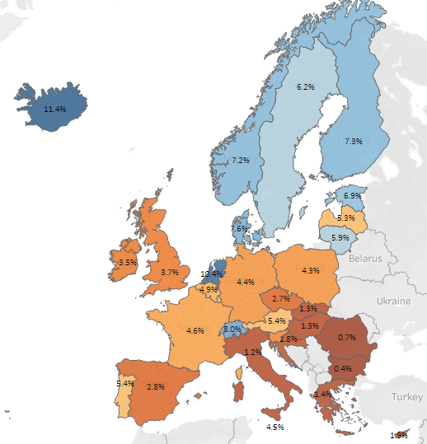
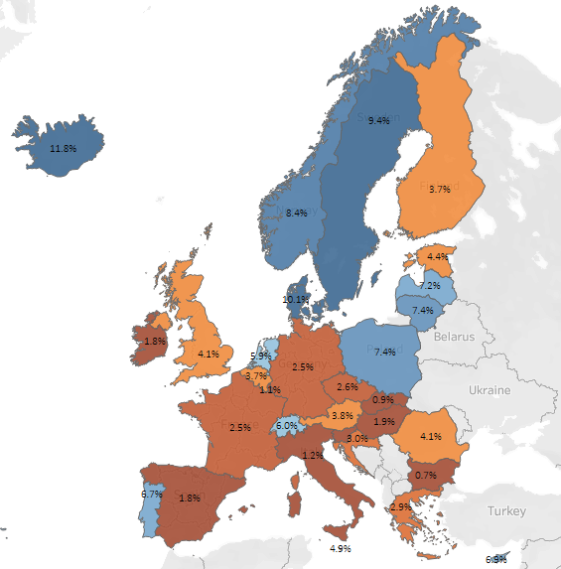

- CHARACTERISTICS OF THESE WORKERS

Regression analysis: summary

In order to answer the question of who takes up secondary employment work and how this differs by various characteristics, we run a regression analysis examining secondary employment in Ireland. Due to the number of categorical variables in our model, we run a logit model and examine marginal effects showing the proportion of workers who had more than one job over the period Q1 2019 to Q2 2023. The results are shown in Table 3a. Furthermore, a quarter-by-quarter analysis is presented in an Annex to this work. This demonstrates that the general patterns observed have remained quite static over the period examined.

An additional iteration of this analysis was run to determine if there was an interaction between gender and education on the probability of having a second job. This interaction was found to be significant (Table 3b) and is demonstrated via the predictive margins for this interaction. The analysis indicates that the effects of education on the probability of having a second job is significantly stronger for women than men.

The results presented here suggest that females are significantly less likely to have a second job than males, people working in the agricultural sector are more likely to have a second job when compared with all other sectors and that Irish people are more likely to have a second job than non-Irish nationals. In relation to education level, our results show that when compared with those with low education levels, those with a high education level are more likely to have a second job. Furthermore, people working part-time are significantly more likely to have a second job than people working full-time as are those living in Western and Border areas (compared to other regions).

Table 3a: Marginal Effects Showing Proportion who have a Second Job (LFS 2019 Q1-2023 Q2)

 |  | Weighted %
Gender | Male | 4.30
Gender | Female | 2.30***
Year | 2019 | 3.02
Year | 2020 | 2.83
Year | 2021 | 3.35**
Year | 2022 | 3.55***
Year | 2023 | 3.51***
Age | 20-24 | 2.14
Age | 25-44 | 3.07***
Age | 45-64 | 3.89***
Age | 65+ | 1.93
Education | Low | 2.49
Education | Medium | 2.82**
Education | High | 3.77***
Nationality | Irish | 3.45
Nationality | Non-Irish | 2.04***
Region | North & West | 4.60
Region | Southern | 3.50***
Region | East & Midlands | 2.56***
NACE | Agriculture | 6.40
NACE | Industry | 2.51***
NACE | Construction | 3.35***
NACE | Trade | 2.68***
NACE | Transportation and Storage | 3.03***
NACE | Accommodation and Food | 2.22***
NACE | Information and Communication | 2.56***
NACE | Financial | 1.95***
NACE | Professional Scientific | 3.99***
NACE | Admin and Support | 3.62***
NACE | Public Admin. | 2.63***
NACE | Education | 4.84***
NACE | Health | 3.24***
NACE | Other | 3.03***
Characteristics of Main Work | Full-Time | 2.63
Characteristics of Main Work | Part-Time | 6.54***
Family Status | Children U18 | 3.26
Family Status | Children 18+ | 3.16
Family Status | No Children | 3.28
Notes: Reference categories for regression analysis are highlighted in bold and italics. *** p<0.001, **p<0.01, *p<0.05.
Table 3b: Interaction – Factors Associated with Having a Second Job (Odds Ratio), 2022

 |  | 2022
Gender | Male
Gender | Female | 0.19***
Age | 20-24
Age | 25-44 | 1.47**
Age | 45-64 | 2.03***
Age | 65+ | 0.92
Education | Low
Education | Medium | 1.06
Education | High | 1.32*
Nationality | Irish
Nationality | Non-Irish | 0.50***
Region | North & West
Region | Southern | 0.80***
Region | East & Midlands | 0.63***
NACE | Agriculture
NACE | Industry | 0.31***
NACE | Construction | 0.48***
NACE | Trade | 0.40***
NACE | Transportation and Storage | 0.43***
NACE | Accommodation and Food | 0.38***
NACE | Information and Communication | 0.50***
NACE | Financial | 0.26***
NACE | Professional Scientific | 0.64***
NACE | Admin and Support | 0.55***
NACE | Public Admin | 0.31***
NACE | Education. | 0.79*
NACE | Health | 0.48***
NACE | Other | 0.48***
Characteristics of Main Work | Full-Time
Characteristics of Main Work | Part-Time | 3.06***
Family Status | Children U18
Family Status | Children 18+ | 0.93
Family Status | No Children | 0.99
Gender # Education | Female # Low Education
Gender # Education | Female # Medium Education | 2.55***
Gender # Education | Female e# High Education | 3.10***

Gender and age

By mid-2023, 41 per cent of people with multiple jobs in Ireland were female (up from below 25 per cent in 2002). Males are still more likely hold multiple jobs, with 3.9 per cent of employed males in this category (3.0% of employed females). This is despite 70 per cent of part-time workers being female, likely due to unpaid caregiving duties limiting their time for additional paid employment. Interestingly, female employees are more likely than males to have a second job, possibly for care-related reasons (Revenue Commissioners, 2023). Ireland ranks poorly on childcare policies, placing 36th out of 41 in UNICEF’s 2021 report “Where do rich countries stand on childcare” (Gromada and Richardson, 2021). High childcare costs act as a barrier to employment, contributing to Ireland having the 7th lowest female share of multiple job holders in the EU. The EU average is a 50-50 gender split, while in the UK, 57 per cent of multiple job holders are female.
The likelihood of having a second job increases with age. For instance, those aged 25–44 years are significantly more likely to have a second job compared to those aged 20–24 years, but to a lesser degree than those aged 45-64 years. The age distribution of people with second jobs in Ireland shows that the largest group is 45-64-year-olds (50%), followed by 25-44-year-olds (35%), 15-24-year-olds (10%), and those aged 65 years and above (6%). In the case of the latter cohort, the equivalent figure was one per cent in 2002. This reflects broader employment growth in this age group. The increase in full-time education among 20-24-year-olds – from 31.2% in 2013 to 37.5% in 2021 – likely contributes to their lower employment and secondary job rates.

Educational Attainment

Persons with secondary employment in Ireland are typically highly educated. By late-2022, 57 per cent of this cohort had completed tertiary level education. This share has grown significantly over the last 20 years. In Q2 2002, 27 per cent of persons with a second job had a tertiary level education and 36 per cent had completed only primary level education. Those with multiple jobs are now slightly more likely to have completed third-level education than the workforce as a whole (at 57 per cent and 53 per cent, respectively). Approximately 13 per cent of persons with multiple jobs have completed primary level education only. This is the slightly higher than for the workforce at large. These shares are different for men and women. Just 50 per cent of male second-job holders have a tertiary level education, compared to 65 per cent of females. At the other end of the spectrum, 18 per cent of male multiple job holders have a primary level education only (compared to six per cent of females).

Nationality

Non-Irish nationals constitute a significant portion of Ireland's workforce. This cohort accounted for 20 per cent of total employment by 2023, up from 4 per cent in 2002. A high volume of employment permit applications have been received in recent years with 31,000 permits granted to non-EEA nationals in 2023 alone. This growth has helped address labour shortages across various sectors. Despite their significant presence in the workforce, the share of non-Irish nationals with secondary employment has risen only modestly and now stands at 12 per cent. This disparity may stem from restrictions on non-EEA nationals with employment permits (i.e. ineligible to hold multiple jobs). The disparity may also be partly as a result of the high prevalence of secondary employment in the agricultural sector, which is dominated by Irish nationals.

Where do persons with two jobs live?

The regional analysis presented here refers to the region of residence of multiple-job holders, rather than region of employment. It could be the case that some multiple-job holders work across several NUTS3 regions, or indeed in Northern Ireland. The available data are not sufficient for us to comment on commuting patterns. The CSO have, however, provided data on the number of persons with two or more jobs who work from home in their main job. At present, 43 per cent of persons with secondary employment ‘sometimes’ or ‘usually’ work from home in their primary job, compared to 34 per cent of persons in employment overall. The share of persons with secondary employment working from home has remained consistently above the level for the workforce more broadly.
Even in 2002, close to one-third of persons with secondary employment ‘sometimes’ or ‘usually’ worked from home, compared to 15 per cent of all persons in employment at the time. This could provide some evidence that the ability to work from home frees up (commuting) time for persons to take up secondary employment. Williamson (2022), for example, has found that remote workers in Ireland can save an average of 93 hours per year through not commuting – and in some cases this can be higher – while there is also evidence to suggest that remote working can improve employee wellbeing and reduce stress. This would potentially give workers more mental and physical capacity to take on additional employment.
Those engaged in agriculture (and working on their own land) are, however, included within these numbers. As demonstrated in Section 4, there are a disproportionately high number of persons working in agriculture and with secondary employment.
In addition, LFS data suggests that remote working has not had a major impact on secondary employment rates since the start of the pandemic. Since early-2020, the (primary) occupations with the largest increases in numbers of persons with a second job are skilled agricultural/forestry/fisheries workers; technicians and associate professionals; and service/sales workers. These are not occupations that are typically well-suited to remote working. Over the period considered here, persons have been relatively less likely to hold a second job working in industry. The share has remained unchanged at close to eight per cent over time, albeit that there has been a degree of volatility post-2010.

Figure 3.1: Number of persons with secondary employment in Ireland (aged 15 years+) ‘sometimes’ or ‘usually’ working from home in their primary job, and shares of employment of this cohort, 2002 – 2023
Figure 3.3: Share of persons with second job as a percentage of NUTS3 regions’ overall employment, Q2 2023

Figure 3.2: Number of employed persons (1000s) in Ireland having a second job by NUTS3 region, Q2 2023

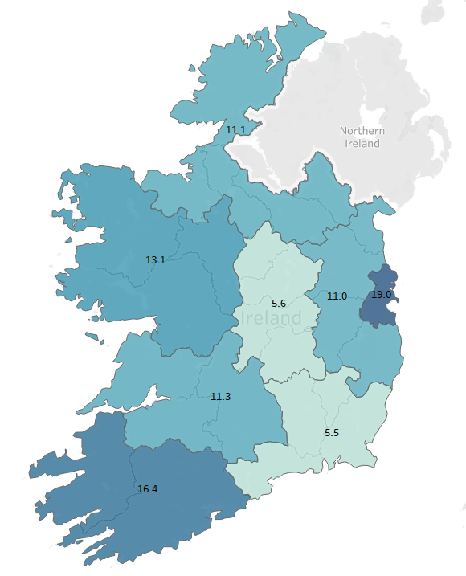
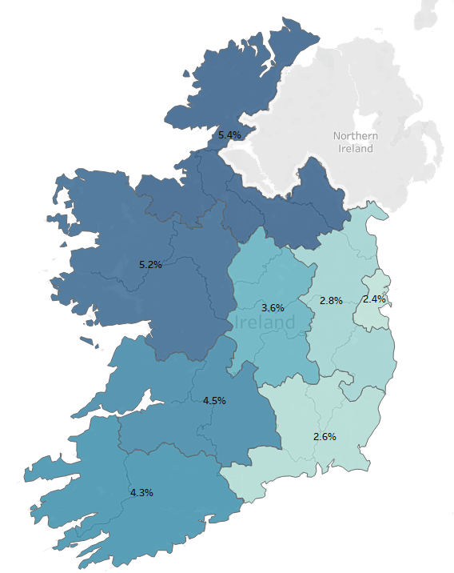

The Dublin and South-West regions have the highest numbers of persons with secondary employment (Figure 4.2). Approximately 19,000 persons in Dublin have multiple jobs compared to 16,400 in the South-West. The Midland and South-East regions contain significantly fewer numbers of such workers. This is not surprising, given that Dublin and the South-West have the highest population levels in the country. When looking at the share of persons with multiple jobs in each region, a different picture emerges. The Border region has the highest rate of persons employed with multiple jobs (5.4 per cent). Dublin has the lowest (2.4 per cent). Over the past five years, the highest growth in the numbers of persons employed in multiple jobs has been in the regions surrounding Dublin. Whilst Dublin experienced a 52 per cent increase in the number of multiple-job holders, the Mid-East has experienced a 86 per cent rise. This could be as a result of the continuing shift towards services activity. These are typically located in urban areas.

- SECTOR AND OCCUPATION

Sector of employment in secondary job

Looking at the sectoral breakdown of secondary employment (see Table 4), second jobs tend to be concentrated in the agricultural and services sectors. The latter has undergone significant expansion in recent years. The services sector, as defined here, includes a wide range of activities including transportation, hospitality, finance, healthcare, and education. Gig economy activities such as food delivery, ride-hailing or cleaning services are also included within the services sector.
In the Celtic Tiger period, the services sector made up 51.9 per cent of persons with a second job, with over 39 per cent of persons working in agriculture. By 2023, 26 per cent of those with secondary employment work in agriculture in their second job, compared to c.66% per cent working in services. Although the relative share of persons with a second job in agriculture fell, the absolute numbers have continued to increase. There are now 6,900 more people employed in a second job in the agricultural sector compared to 2002.
There has been a significant increase in service sector second jobs since the onset of the pandemic, increasing by 8 percentage points between the Covid-19 Pandemic period and Post-Pandemic Recovery period. Post-pandemic challenges in terms of filling vacant positions could have resulted in employers being more willing to hire staff only able to work part-time hours, thus making it easier for persons to find part-time secondary employment. Structural changes in the labour market as a result of COVID-19, such as an increased prevalence of remote working, could also have contributed to this trend.
Table 4: Trends in Sector of Secondary Employment (2002-2023)
Time Period | Celtic Tiger (2002-2006) | Global Financial Crisis (2007-2012) | Post-Crisis Recovery (2013-2019) | Covid-19 Pandemic (2020 –2021) | Post-Pandemic Recovery (2022- 2023)
Agriculture, Forestry and Fishing
Number of persons (000s) | 15.4 | 15.7 | 18.3 | 24.0 | 23.8
Share of secondary employment | 39.4% | 33.1% | 33.7% | 34.3% | 26.0%
Industry
Number of persons (000s) | 2.9 | 3.4 | 4.2 | 6.3 | 6.5
Share of secondary employment | 7.4% | 7.1% | 7.5% | 8.0% | 7.3%
Services
Number of persons (000s) | 20.1 | 27.0 | 30.9 | 41.9 | 60.1
Share of secondary employment | 51.9% | 58.8% | 56.3% | 57.9% | 65.8%

Sector of employment in primary job

Although persons are unlikely to hold a second job in Industry, 17.7 per cent of second job holders work in ‘Industry and Construction’ in their primary job. This is marginally lower than the sectoral share these two sectors make up of employment overall (18.4 per cent). Approximately eight per cent of second job holders work in agriculture in their primary job, higher than the four per cent share the sector makes up of employment overall, although significantly lower than its share of employment within second jobs (23 per cent). Over three quarters of those with secondary employment work in the Services sector in their primary job. This sectoral share has risen by 22 percentage points in the last two decades, in-line with employment trends more broadly.

Figure 4.3: Employed persons (aged 15 years +) having a second job by sectoral share of employment in primary job, 2002-2023

Source: Authors’ calculations from CSO data

Occupation in Primary Job

A large proportion of multiple-job holders work in high-skilled, white-collar occupations in their primary job. For example, approximately 39 per cent of persons with second jobs work in professional and managerial roles in their primary job, as indicated on Figure 9 below. This share is slightly higher than the share these occupational groups make up within the labour market as a whole (32 per cent). The high share of professionals and managers having second jobs is not a recent phenomenon. Two decades ago, in 2002, approximately 46 per cent of persons with a second job worked in these occupations in their primary job, while 20 per cent worked in lower skilled Elementary of Plant and Machine Operator occupations. Today, just 6 per cent of persons with a second job work in Elementary or Plant and Machine Operator Occupations, and the occupational share of Clerical Workers and Service and Sales workers is also low. In fact, these shares are lower than the shares these occupational groups make up within employment overall. This data challenges the conventional wisdom that the majority of multiple job holders are low-wage earners or persons who live in low-income households (sometimes referred to workers attempting to ‘keep their heads above water’). Instead, the data reveals that a typical multiple-job holder in Ireland is highly educated and works in a professional or managerial role in their primary job. In some of these cases, persons may perceive some economic necessity to work a second job (despite the fact they are employed in relatively high-paying primary jobs).

Figure 4.4: Employed persons (aged 15 years +) having a second job in Ireland by occupation in first job (per cent), 2002-2023

Source: Authors’ calculations from CSO data

The occupational distribution in Ireland is similar to that of the EU as a whole: within the EU, professionals are also the occupational group most likely to hold a second job. Research by Eurofound, found that primary occupations of multiple-job holders vary significantly for men and women, however. Across the EU, on average, female multiple-job holders are far more likely to work in Elementary or Service and Sales occupations in their primary job compared to men. Indeed, the most popular primary occupation for female multiple-job holders in 2015 across the EU was ‘Cleaners and Helpers’. This suggests that secondary employment amongst women may be driven by low pay, and primary job quality. This work also found that a large share of women with more than one job (40 per cent) are among the lowest quintile of earners (in their main job), while the largest share of men (30 per cent) are in the top quintile. Across the EU, women account for 51% of those with secondary employment (compared to 41% in Ireland).

While female multiple-job holders are marginally more likely to work in high paying professional or managerial roles in their primary job than men, a significantly higher share of women work in Service and Sales roles in their primary job – occupations that are typically characterised by low pay. Approximately 26 per cent of female multiple-job holders work as a Service and Sales worker in their primary job in Ireland, compared to 10 per cent of men. As well as being characterised by low pay, these roles typically have high shares of persons working part-time. It may be the case that women working in these roles want to work more hours in their primary job, but are unable to do so, so instead find additional employment. Service and Sales roles also typically allow for atypical working hours, which may suit women with caring responsibilities. Holding multiple part-time roles could provide flexibility in this regard, without sacrificing pay, compared to holding one full-time job.

Figure 4.5: Occupation in first job (of multiple-job holders) in Ireland and the EU 27 average in Q2 2023 (by gender)

Source: Authors’ calculations from CSO data

- EMPLOYMENT STATUS AND HOURS WORKED

Employment status in both jobs

The number of self-employed persons (in their primary job) in Ireland today is only slightly above levels seen two decades earlier. There are currently c. 335,000 self-employed persons (c. 295,000 in 2002). As a share of total employment, however, the number of self-employed persons in Ireland has fallen to 13 per cent (down three percentage points) (Figure 5.1). This is despite the fact that many platform (or gig) economy workers are classified as self-employed. Research suggests, however, that many of the latter perform such work as a secondary job. If this is the case, it is not necessarily surprising that there has not been an increase in the number of self-employed persons (in a primary job) in Ireland in recent years. It may also be the case that platform work is indeed popular amongst those with a second job but that it has replaced other activities rather than stimulating new secondary employment.

Figure 5.1: Number of self-employed persons (aged 15 years +) in Ireland, and as a share of total employment, 2002 - 2023

Source: Authors’ calculations from CSO data

Looking specifically at the employment status of persons with multiple jobs, there are four potential combinations to be considered here: (i) persons who are employees in both their primary and secondary employment; (ii) persons who are self-employed in both jobs; (iii) persons who are an employee in their primary job but self-employed in their second job; and (iv) persons who are self-employed in their primary job but are an employee in their second job. Most multiple-job holders are employees in both their first and second jobs (40 per cent) or they are employees in their first job and self-employed in their second (36 per cent). The combinations of self-employed–employee (10 per cent) and self-employed–self-employed (15 per cent) are less common. Employment status in someone’s first job seems to have little impact on whether they are an employee or self-employed in their second job. Over 86 per cent of persons across the labour market are employees in their primary job (compared to 76 per cent of multiple-job holders). One might have expected a similar pattern to emerge for a person’s employment status in a second job. There is, however, a 50-50 split between persons who are self-employed and employees in their secondary employment. These shares are not uniform for males and females (Figures 5.2 and 5.3).
Figure 5.2: Employed persons having a second job by employment status in both jobs, 2002-2023

Source: Authors’ calculations from CSO data

Figure 5.3: Employment status in first and second job in thousands of persons by gender, Q2 2023

Source: Authors’ calculations from CSO data

Whilst 40 per cent of those with secondary employment are employees in both jobs, women (60 per cent) are more likely than men to do so. This may suggest that men and women hold second jobs for different reasons. The proportion of workers opting for this combination grew significantly (up 12 percentage points) during the period 2020-21. This could be linked to the concept of “necessity” secondary employment where workers – whose incomes had perhaps taken a hit during the COVID-19 pandemic – felt the need to find additional paid employment. It might also reflect a greater availability of opportunities to work a second job as inward migration slowed and new patterns of consumer behaviour emerged (i.e. a greater take-up of food delivery services). An employee-employee combination may be related to underemployment in a primary job. For instance, a person may be willing to undertake more hours in their primary job but are not offered the chance to do so. Panos et al. (2014) have found that holding a second job is typically transitory in nature and is often associated with career shifts. It therefore might not necessarily be the case that persons in this employee-employee category are underemployed in their primary job, but rather they are seeking to develop skills in a different sector to their primary job, before making the switch permanently.
For men (42 per cent), the most typical combination is to be an employee in their primary job and self-employed in their secondary employment. Just 26 per cent of women fall into this category. The incidence of the employee: self-employee combination has fallen over time. The share of secondary employment accounted for by this cohort two decades ago was 38 per cent. This increased to 43 per cent in 2018 but has since fallen back to 36 per cent. Although the employment share for this cohort has declined in recent years, the number of persons categorised as employee: self-employee increased by 11,700 (55 per cent) between 2020 and 2022. This sudden growth during the pandemic could be linked to the concept of opportunity self-employment, where persons temporarily furloughed by their primary employer might have used their newfound free time to explore self-employment opportunities. Alternatively, persons in the employee: self-employee cohort may take up secondary employment for business development reasons. A stable ‘employee’ primary job may help to insure against the possible revenue fluctuations of a fledgling (or start-up) business. Other persons in this category may have broad professional and social networks which give rise to opportunities to undertake additional paid work. Similar ‘insurance’ reasoning may apply to workers who are self-employees in their primary job, and employees in their secondary employment (with the secondary employment in this case helping to smooth income).
A final cohort of interest related to those that are self-employees in both jobs. Approximately 21 per cent of male second-job holders fall into this category, compared to 11 per cent of women. Again, it is unknown exactly which activities persons in this group undertake in either job – whether they are two related trades, in Agriculture, for example, or two completely different sectors of employment. The overall share of persons in this category has fallen over time and now stands at 17 per cent (down five percentage points since 2002).

An analysis of hours worked
The majority (63 per cent) of those with secondary employment report working full-time in their primary job. The rate at which those persons working part-time in their primary job are opting to take-up secondary employment has been increasing. The number of persons in part-time employment in their primary job and who have a second job increased by 335 per cent since 2002. For those working on a full-time basis in their primary job, the rate of increase was 118 per cent over the same period (Figure 5.4). This is consistent with data presented in Section 1 which showed that the number of persons employed part-time in Ireland overall had outstripped the growth rate of full-time employment since 2002. In terms of hours worked, the average number of weekly hours worked in a second job in Ireland has fallen over time, although not uniformly. The average number of hours worked in a second job was 16.4 in early-2008, rising as high as 19.2 hours by late-2016. The most recent data shows that the average number hours worked in a second job was13.8 hours per week in 2023.
Figure 5.4 below presents the average number of weekly hours worked in a second job for people who work full-time in their primary job versus part-time in their primary job. Those who work full-time in their primary job tend to work more hours in their second job than people who work part-time in their first job (14.7 hours and 12.1 hours, respectively). Given that 58,500 persons with secondary employment work full-time in their primary job, there is therefore a large cohort of persons who are working at least 45 hours a week (i.e., those that work full-time in their primary job and work an average of 14.7 hours per week in their second job). This is a conservative estimate, as many full-time employees would work far more than 30 hours in their primary job. Since 2008, hours worked in a second job for persons working full-time in their primary job have fallen by 13 per cent, compared to a 23 per cent fall in hours worked for persons working part-time in their primary job. There is a clear seasonality effect in terms of average hours worked – in a second job – by persons with secondary employment. Figure 5.5 shows how the average hours worked typically spike in Q3 each year. One likely reason for this is that harvest time falls in Q3 and there are a relatively large share of multiple-job holders working in agriculture.

Figure 5.4 Number of persons with a second job by part-time and full-time employment status in primary job (aged 15 years +), and percentage increase since Q2 2002, 2002-2023

Source: Authors’ calculations from CSO data

Figure 5.5: Average number of hours worked in second job by full time/part-time status in primary job, 2008-2023

Source: Authors’ calculations from CSO data

These patterns, however, do vary by gender. Males with secondary employment work an average of 4.6 hours per week more in their second job than do their female counterparts. This differential is present whether persons are working full-time or part-time in their primary job, albeit that the scale of the gap in average hours worked has fallen over time. In early-2008, males worked an average of 18.3 hours in a second job. This rose to 21.6 hours by late-2016, before falling to 15.6 hours by 2023. Conversely, females worked an average of 11.6 hours in a second job in 2008. This is only slightly more than the average hours worked in a second job for that cohort in 2023. The variance in average weekly hours worked in a second job by gender are presented in Figure 5.6. The long weekly hours of certain cohorts will potentially have implications for health and safety in the workplace, as well as for an individual’s work-life balance. Long working hours have been identified as a contributing factor to serious health problems, while mistakes leading to injury in the workplace may increase due to the greater incidence of fatigue associated with working longer hours. There could also be implications for labour productivity for the same reasons. Output per hour worked may decrease if workers are fatigued from working too many hours across multiple jobs.

Figure 5.6: Average number of weekly hours worked in second job in Q2 2023, by gender and full-time/part-time status in primary job

Source: Authors’ calculations from CSO data
Looking at a comparison for Ireland and the EU, Irish residents with secondary employment work significantly more hours in those jobs than the EU average. At present, however, a lower share of persons hold secondary employment in Ireland than across the EU. In Ireland, persons with second jobs work an average of 13.8 hours per week in that job, compared to an EU average of 11.2 hours. There is, however, a significant degree of intra-country heterogeneity here. While Scandinavia has very high rates of persons with second jobs, people tend to work fewer hours in that job than the EU average. The opposite is true in eastern and southern European countries. These differences are displayed Figures 5.7 and 5.8. Why Ireland once again remains an outlier amongst small, advanced, European countries is unknown, although the high proportion of males in secondary employment in Ireland is likely a contributing factor. Cultural differences, the share of secondary employment in agriculture, and the degree to which secondary employment is a necessity to supplement income would all also influence levels of hours worked in a second job, for example, but the available data preclude any definitive conclusions from being drawn here (particularly given the events of recent years). As with the numbers of persons with a second job overall, hours worked in a second job in Ireland has been converging on the EU average in recent years.
Finally, there is a slight inverse relationship between the number of persons employed in multiple jobs across the EU27, and the number of hours worked in a second job. As with secondary employment’s relationship with the shadow economy, discussed in Section 1, the relationship between incidence rates of secondary employment, and average hours worked is an area that could merit further exploration in future research.

Figure 5.8: Average number of hours worked in second job across the EU, Q2 2023

Figure 5.7: Average number of hours worked in second job across the EU, Q1 2008

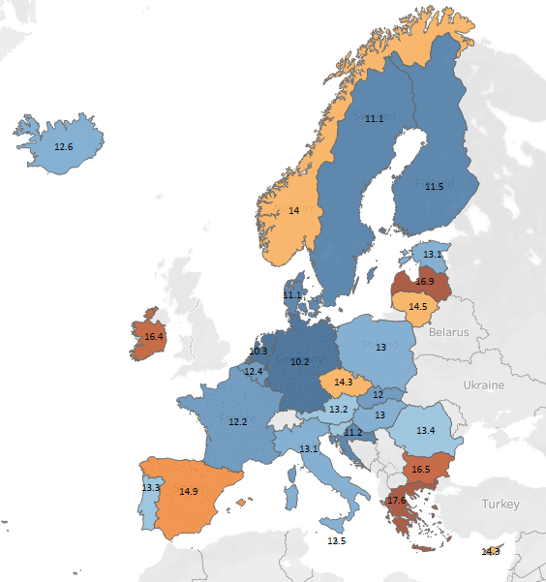
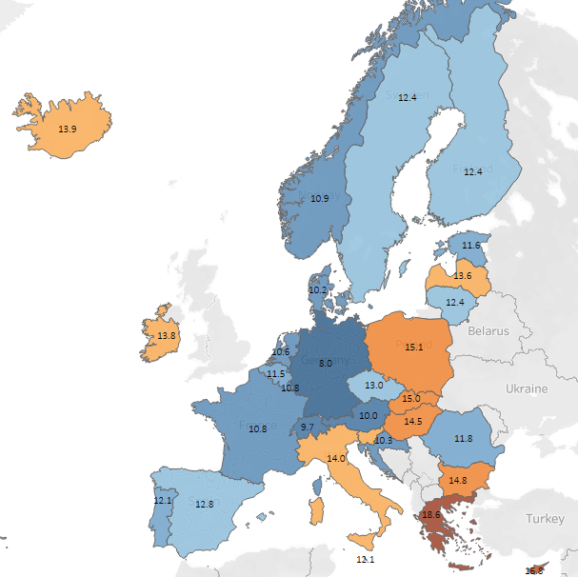

6. CONCLUDING COMMENTS

This paper has provided a detailed overview of the characteristics of people with secondary employment in Ireland, and the factors which influence whether someone has more than one job. Whilst it may have been reasonable working assumption at the outset that multiple-job holders were more likely than not to be low-income workers and male (perhaps working in the agricultural sector), this paper demonstrates that secondary employment is a multifaceted phenomenon. While there is no such thing as a ‘typical’ multiple-job holder in Ireland, this paper has found that persons with multiple jobs are more likely than not to be male, middle-aged and highly educated. It also demonstrates that they tend to work in the services sector in their second job, are equally likely to be an employee or self-employee in their secondary employment and that whilst most of those with secondary employment are indeed males, female workers account for an increasing share of the broader cohort. The question of whether the incidence rate of secondary employment can be used as an indicator for primary job quality can therefore be answered: it is not necessarily a reliable proxy. The high share of highly educated workers who take up secondary employment suggest that multiple-job holders take up additional employment for a multitude of reasons. A perceived need to supplement income is just one reason and there may well be some people with a high level of education and working in professional roles but who feel a financial imperative to work an extra job. Skills diversification, setting up a business or using a second job as a stepping-stone to career advancement are likely also important reasons behind secondary employment.
Despite the rapid recent rise in secondary employment in Ireland, the incidence rate here remains some way below the EU average. The relatively low share of female multiple job holders in Ireland compared to other EU countries may explain some of this gap. High costs of childcare can act as a barrier to work for women in Ireland (or to additional employment in the case of those already in employment). The rising level of female participation, and the growing number of female workers with secondary employment, may well see Ireland converge over time. At the outset it seemed plausible that the rising prevalence of platform work – as well as remote working – have been determinants of the rise in secondary employment. We find little evidence to suggest that either trend has been a major factor. Although the number of persons who are self-employed in their second job has increased in recent years, this has been far outstripped by the number of persons who are employees in their second job. In practice, it may be that platform work is largely utilised as a primary job amongst young people (alongside full-time study). This paper, however, has only explored secondary employment that is captured in official statistics. There is evidence to suggest that ‘informal’ digital platform workers outnumber persons working in informal jobs in the traditional economy (Aleksynska, 2021). Furthermore, Williams, Llobera Vila and Horodnic (2020) found that many workers operating on digital platforms may inadvertently be non-compliant with employment (or tax) regulations.
The paper also examined patterns in the volume in hours worked for those with secondary employment. Hours worked in second jobs are high in Ireland, but there are once again heterogenous effects across genders. There is a large cohort of persons who work full time in a primary job, and long hours in a second job – raising concerns around health and safety, labour productivity, and work-life balance. There are also implications for a person’s ability to engage with lifelong learning. A useful piece of future research would be to examine this group in more detail, to better understand the motivations behind working such long hours, and the impacts on the policy areas discussed above. This research has shed light onto a previously under-researched area. Many questions still remain, however, including the motivations behind the take-up of secondary employment, the relationship between secondary employment and shadow labour markets and the extent to which Government policy can influence incidence rates. Although requiring supplementary income is just one factor behind secondary employment, recent inflationary pressures could result in more persons seeking additional employment over time. This paper is intended as a contribution to the public discussion around changing labour market dynamics but this is a theme that merits further research, including with regard to the extent to which secondary employment might develop into full-time self-employment (and why).

REFERENCES
Aleksynska. (2021). “Digital Work in Eastern Europe: Overview of Trends, Outcomes and Policy Responses”. ILO Working Paper 32.

Barrero, J.M., Davis, S. J. and Bloom, N. (2023). “The Evolution of Work From Home”. Journal of Economic Perspectives. 37 (4). 1-28. The Evolution of Working from Home | Stanford Institute for Economic Policy Research (SIEPR)

Bloom, N., Han, R., Liang, J. (2023). “How Hybrid Working From Home Works Out”. NBER Working Paper Series. How Hybrid Working From Home Works Out

Boyd, Keenan and McIndoe-Calder. (2021). “Labour Market Recovery After a Pandemic”, Central Bank of Ireland.

Boyd, Keenan, and McIndoe-Calder. (2022). Recent Developments in the Irish Labour, Market. Quarterly Bulletin 1 – Box G, Central Bank of Ireland.

Burke, Fu, Sun and Sheehan. (2022), “Ireland’s Project Economy 2022: A barometer of independent professionals, contractors and solo self-employed”, Trinity College Dublin Press.

Campion, Caza, and Moss. (2019). Multiple Jobholding: An Integrative Systematic Review and Future Research Agenda. Journal of Management (46). Multiple Jobholding: An Integrative Systematic Review and Future Research Agenda | Request PDF (researchgate.net)

Coates, Dwan-O’Reilly and McNelis. (2021). “IGEES Working Paper: Employment transitions of people closing Pandemic Unemployment Payment claims”: www.gov.ie/pdf/?file=https://assets.gov.ie/232911/1f7ac98f-75d0-4b6f-8bad-00a3e421cd12.pdf#page=1

Conen, and de Beer. (2021). “When two (or more) do not equal one: an analysis of the changing nature of multiple and single jobholding in Europe”. Transfer: European Review of Labour and Research, 27(2), 165-180. When two (or more) do not equal one: an analysis of the changing nature of multiple and single jobholding in Europe (ssoar.info)

Conen. W. and Schulze Buschoff, K. (2021). “Introduction to the special issue: multiple jobholding in Europe”. Transfer, 27(2), 141-147. 10242589211022550.pdf

Dillon, Donnellan, Moran and Lennon. (2024). Teagasc National Farm Survey 2023. Teagasc – the Agriculture and Food Development Authority. 2024 - Teagasc National Farm Survey 2023 - Teagasc | Agriculture and Food Development Authority

Eurofound (2020), “Privilege or necessity? The working lives of people with multiple jobs”, European Working Conditions Survey 2015 series, Publications Office of the European Union

Fairlie and Fossen, (2018), “Opportunity versus Necessity Entrepreneurship: Two Components of Business Creation”, IZA Discussion Paper Series.

Guariglia and Kim. (2004). Earnings uncertainty, precautionary saving, and moonlighting in Russia. Journal of Population Economics. 17 (2). pp. 289-310. EconPapers: Earnings uncertainty, precautionary saving, and moonlighting in Russia (repec.org)

Gromada and Richardson, (2021), “Where do rich countries stand on childcare”, UNICEF Office of Research.

Murphy (2023). “New insights using Revenue’s PAYE real-time data”, Office of the Revenue Commissioners. Examining the Tax Base; Parcels, Properties and People - combined presentations (revenue.ie)

Medina and Schneider, (2018), “Shadow Economies Around the World: What Did We Learn Over the Last 20 Years?”, IMF Working Paper.

Obermaier and Koch. (2014). “Mind the gap: Consequences of inter-role conflicts of freelance journalists with secondary employment in the field of public relations”. Journalism. 16 (5). (PDF) Mind the gap: Consequences of inter-role conflicts of freelance journalists with secondary employment in the field of public relations (researchgate.net)

Panos et al., (2014), “Multiple Job Holding, Skills Diversification, and Mobility”, Industrial Relations, 53(2), pp. 223-272.

Piasna, A., Pedaci, M. and Czarzasty, J. (2020). “Multiple jobholding in Europe: features and effects of primary job quality”. Transfer European Review of Labour and Research. 27(4).: DOI:10.1177/1024258920958836

Raffiee and Feng. (2014). “Should I quit my day job? A hybrid path to entrepreneurship”. Academy of Management Journal, 57(4), 936–963. Should I quit my day job?: A hybrid path to entrepreneurship. (apa.org)

Scott, J., Edwards, K., and Stanczyk, A. (2020). “Moonlighting to the Side Hustle: The Effect of Working an Extra Job on Household Poverty for Households With Less Formal Education”. Families in Society. 101(3). 324-339. https://doi.org/10.1177/1044389420910664

Seema, S., Choudhary, V. and Saini, G. (2021). “Effect of Job Satisfaction on Moonlighting Intentions: Mediating Effect of Organizational Commitment”. European Research on Management and Business Economics. 27(1). https://doi.org/10.1016/j.iedeen.2020.100137

Williams, Llobera and Horodnic, (2020), “Tackling undeclared work in the collaborative economy and bogus self-employment”, EU Platform for tackling undeclared work.

Williamson, (2022), “An Evaluation of the Impacts of Remote Working”, Irish Government Economic and Evaluation Service/Department of Enterprise, Trade and Employment.

ANNEX

 |  | 2022 Q1 | 2022 Q2 | 2022 Q3 | 2022 Q4 | 2023 Q1 | 2023 Q2
Gender | Male | 5.25 | 5.00 | 4.87 | 4.50 | 4.76 | 4.59
Gender | Female | 2.93*** | 2.18*** | 2.29*** | 2.31*** | 2.31*** | 2.66***
Age | 20-24 | 2.53 | 2.56 | 2.10 | 1.94 | 2.66 | 2.48
Age | 25-44 | 3.88 | 3.11 | 3.24 | 2.92 | 2.79 | 3.07
Age | 45-64 | 4.98** | 4.29* | 4.25** | 4.28*** | 4.40* | 4.46**
Age | 65+ | 1.94 | 2.36 | 2.14 | 2.03 | 2.66 | 2.62
Education | Low | 3.66 | 2.40 | 2.75 | 2.62 | 3.15 | 3.29
Education | Medium | 3.72 | 3.37* | 3.44 | 3.37 | 3.27 | 3.34
Education | High | 5.97** | 5.05*** | 4.08* | 3.54 | 4.47 | 4.81*
Nationality | Irish | 4.35 | 3.89 | 3.69 | 3.57 | 3.71 | 0.18
Nationality | Non-Irish | 2.40** | 1.45*** | 2.17* | 2.00** | 2.04*** | 0.40*
Region | North & West | 5.55 | 4.77 | 4.54 | 4.03 | 4.96 | 4.99
Region | Southern | 4.02** | 3.90 | 3.67 | 3.54 | 3.86* | 3.79*
Region | East & Midlands | 3.49*** | 2.72*** | 2.89*** | 2.88* | 2.57*** | 2.85***
NACE | Agriculture | 8.99 | 6.53 | 7.22 | 6.09 | 5.71 | 5.58
NACE | Industry | 2.96*** | 2.12*** | 2.26*** | 1.86*** | 2.44*** | 2.96*
NACE | Construction | 4.51** | 3.89* | 2.78*** | 3.20* | 3.49* | 4.58
NACE | Trade | 4.32*** | 2.67*** | 2.68*** | 2.03*** | 1.71*** | 2.72**
NACE | Transportation and Storage | 4.58** | 3.32* | 2.86** | 2.40** | 2.59** | 2.56*
NACE | Accommodation and Food | 1.86*** | 3.26** | 2.59** | 3.28* | 3.66 | 3.03(
NACE | Information and Communication | 3.16*** | 4.04 | 3.74** | 3.58* | 4.26 | 4.31
NACE | Financial | 2.00*** | 2.13** | 2.42*** | 1.29*** | 1.94** | 1.67**
NACE | Professional Scientific | 4.17*** | 4.50 | 4.11* | 5.37 | 5.26 | 3.97
NACE | Admin and Support | 4.29** | 3.50* | 3.50** | 4.63 | 3.26* | 3.26
NACE | Public Admin. | 2.57*** | 2.05*** | 2.25*** | 2.33** | 2.72** | 2.62**
NACE | Education | 6.19* | 4.24* | 6.46 | 5.59 | 5.19 | 4.97
NACE | Health | 3.72*** | 3.96* | 3.35*** | 3.05** | 3.58* | 3.55*
NACE | Other | 3.38*** | 3.15** | 3.30** | 4.04 | 4.01 | 4.11
Characteristics of Main Work | Full-Time | 3.22 | 2.65 | 2.58 | 2.59 | 2.69 | 2.77
Characteristics of Main Work | Part-Time | 8.39*** | 7.87*** | 8.06*** | 6.76*** | 7.07*** | 7.46***
Family Status | Children U18 | 4.21 | 3.47 | 3.22 | 3.67 | 3.72 | 3.63
Family Status | Children 18+ | 3.71 | 3.31 | 3.55 | 2.99 | 3.33 | 3.35
Family Status | No Children | 4.14 | 3.63 | 3.60 | 3.20 | 3.24 | 3.65

The authors would like to thank colleagues at the CSO’s Labour Market Analysis Unit for their assistance with this research. The authors would also like to express appreciation to attendees at the Dublin Economic Workshop Annual Conference [23rd September 2023] for their constructive comments on an early version of this work which have served to strengthen the analysis.
International Fellow at The Productivity Institute (University of Manchester) and Adjunct Senior Research Fellow at the Geary Institute for Public Policy (University College Dublin).
Corresponding author: dermot.coates@enterprise.gov.ie
Using a month-long definition as a measure for secondary employment. The figure of 85,000 persons refers to PAYE employees with earned income from two or more employers in October 2022. This figure is adjusted for within month job switchers.
Platform work is a form of employment in which organisations or individuals use an online platform to access other organisations or individuals to solve specific problems or to provide specific services in exchange for payment (Eurofound).
Following on from this, the Office of the Revenue Commissioners has issued new guidance to employers for determining employment status for tax purposes.
Mean average annual change
Or what the authors refer to as paid microworks.
Mean average annual change
Due to small sample sizes in the LFS, there are missing values for a number of years under analysis. Any values that are shown should be treated with caution due to these small sample sizes.
In their primary job
More generally referred to as an ‘off-farm income’. This, in part, explains the large number of persons with secondary employment working from home
Compared to the number of persons employed in the region as a whole.
It is also worth noting that just four per cent of the total number of persons in employment work in agriculture.
Note, missing values have been excluded from this analysis.
For example: A record number of Australians are working multiple jobs to 'keep their heads above water' - ABC News
Self-employment is typically defined as the employment of employers, workers who work for themselves and members of producers' co-operatives (OECD).
For instance, where such a person was in receipt of the Pandemic Unemployment Payment they would have been classified as having a second job in the LFS if they anticipated returning to work (in their primary job) within 3 months.
Full-time employment usually refers to employment of 30 hours of more per week in a primary job (OECD).
Note: The Labour Force Survey (LFS) replaced the Quarterly National Household Survey (QNHS) in Q3 2017. The LFS release for Q3 2017 also incorporated revisions to population estimates based on the 2016 Census of Population. The series before and after Q3 2017 may not be directly comparable and users should remember this when examining all changes, both quarterly and annual’

